Android Controlled SpyBot

Microcontrolled based system design lab – CSE 3216

**Submitted to:**

**Murad hasan ANIK, lecturer (aust)**

**Mr. Shoeb Mohammad Shahriar, lecturer (aust)**

**Samin Shahriar Tokey** | 14.02.04.066 **Biozid Niloy** | 14.02.04.070

**Naimul Haque** | 14.02.04.080 **Sharmin Sultana Mohua** | 13.02.04.006

Android Controlled SpyBot

Objectives:

* To navigate places where human can’t reach physically
* To get video live feed from integrated camera
* To control the robot wirelessly from wide range of distance

Features:

* Controller Type: Android App (Browser Based)
* Communication technique: Wi-fi
* Size: diameter of 6.5’’(165 mm)
* Remote control: WiFi AP with 2.417 frequency
* Silent and powerful (LiPo powered)
* High torque motors with grippy wheels

Equipment:

* Processor board: Raspberry pi 3 Model B
* Camera: Pi camera – 5 MegaPixel
* Motors: Micro Gear Motors
* Power: 1100mAh 3C 11.2V LiPo Battery
* Body: Pololu Chassis
* Wheel: Pololu Wheels
* Caster: Steel ball caster

Others:

* Jumper Wires
* L298N Motor Driver IC (Green)
* LEDs
* Custom built platform
* Screws, Glues etc.

Tools:

* Raspbian (OS)
* Windows 10 (OS)
* PuTTY (Software to remote control Raspbery PI through SSH)
* LightTPD (server)
* Library (git://git.drogon.net/wiringPi)
* Library (mjpg-streamer)

HTML Codes:

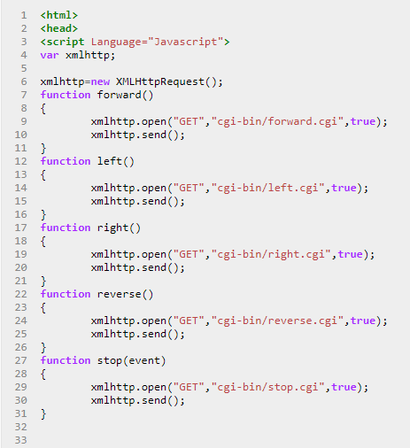

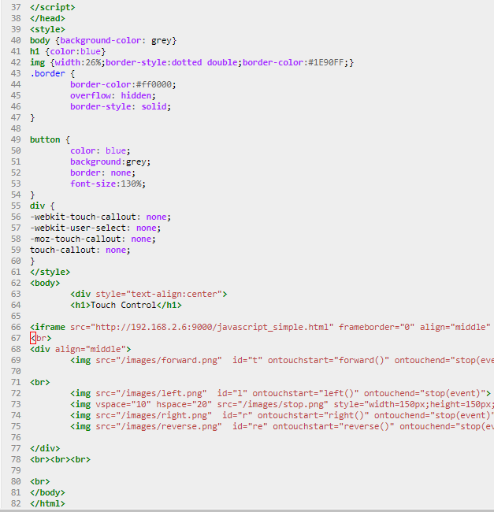

CGI:

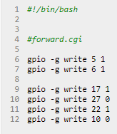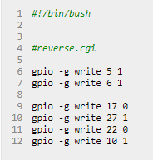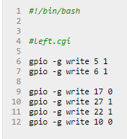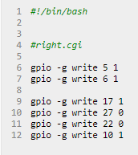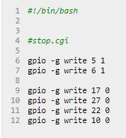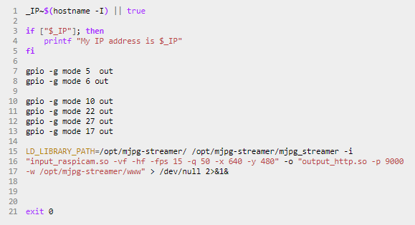  
Conclusion:

We tried our best to make this project a success. We’ve tried to implement all the features we proposed and tried to keep cos at minimum.